

**DESIGNING AND DEVELOPING A WEBSITE**

**Programming Method**

**Module Title**

**NCC Aviation**

**Assignment Title**

**October 2021**

**Examination Cycle**

**THI HAN NAING**

**Candidate Name**

00189889

**Candidate No**

**KMD Computer Centre (Yangon)**

**Centre Name**

**28 January 2022**

**Submission Date:**

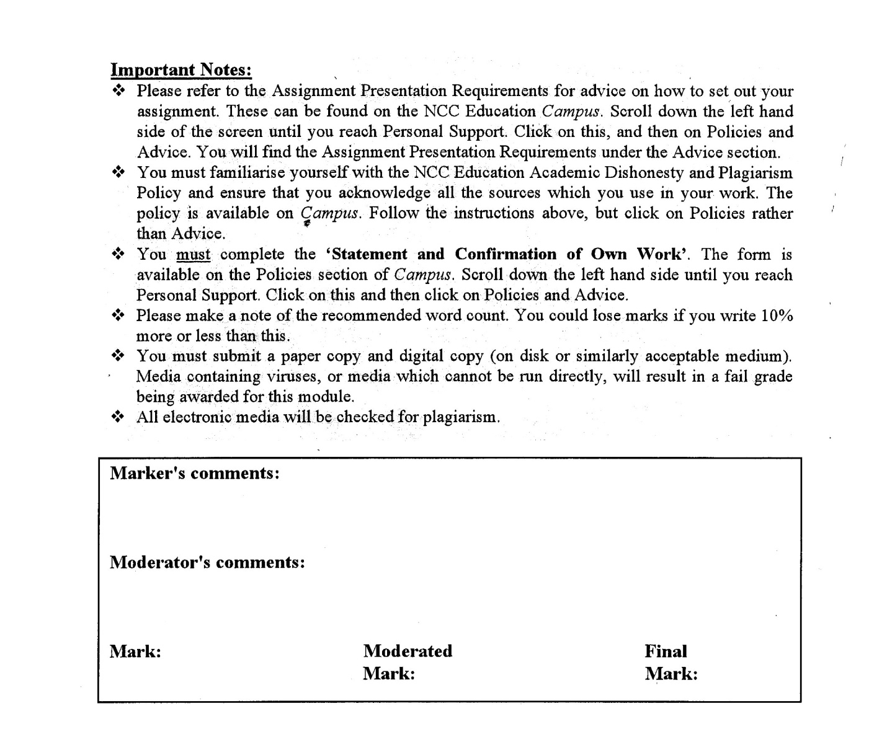



**Statement and Confirmation of Own Work**

**Programme/Qualification name: L4DC/L4DBIT**

*All NCC Education assessed assignments submitted by students must have this statement as the cover page or it will not be accepted for marking. Please ensure that this statement is either firmly attached to the cover of the assignment or electronically inserted into the front of the assignment.*

**Student declaration**

I have read and understood NCC Education’s Policy on Academic Dishonesty and Plagiarism.

I can confirm the following details:

**Student ID/Registration number: 00189889**

**Name : THI HAN NAING**

**Centre Name : Vintage Rally**

**Module Name : DESIGNING AND DEVELOPING A WEBSITE**

**Module Leader : KHIN KHIN LAY KOON**

**Number of words : 1539**

I confirm that this is my own work and that I have not plagiarised any part of it. I have also noted the assessment criteria and pass mark for assignments.

**Due Date : 28 January 2022**

**Student Signature : THI HAN NAING**

**Submitted Date :28 January 2022**

Table of Contents

Introduction 4

Task-1 Web Design Print Screen 6

Task2- CSS Print Screen 8

Task-3 Test the website and write a test report 10

Testing the Website on W3C validation service 10

How the website works for Disable users 10

Testing on Two Different Web Browsers 11

Test Report 11

Role of W3C 11

Task-4 Critical Evaluation 12

Demonstrate a Two accessibility features have in your own website. 12

Functional multimedia components the website have 12

Discussion on how the Internet and Web can be used for the Vintage RallyClub as a business tool 12

Further development for the website. 12

References 13

# Introduction

The assignment is about creating a website for Vintage Car Rally. The assignment included HTML and CSS, testing a website and critical evaluation. The website is responsive and also accessible for disable users. The website is about 2022 Vintage Car events.

**Task 1**

**HTML**

# Task-1 Web Design Print Screen

Home Page

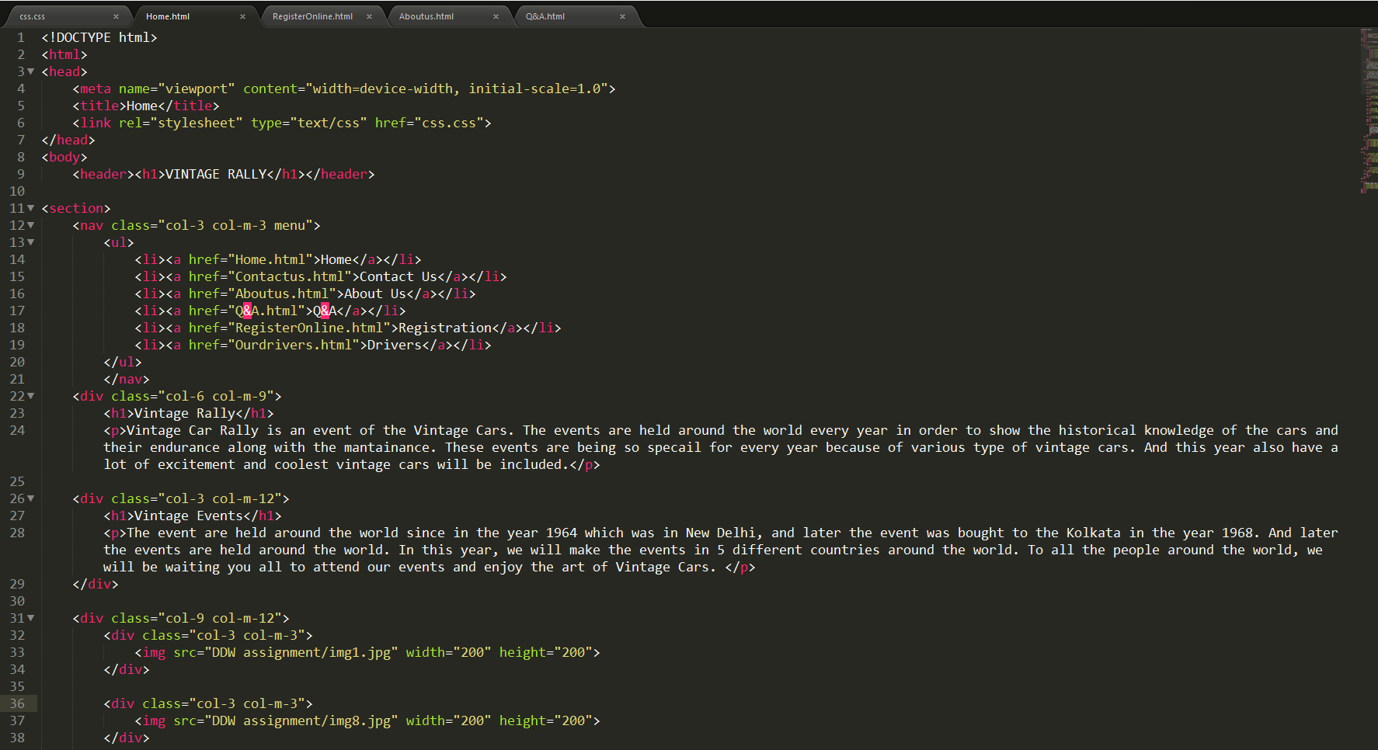

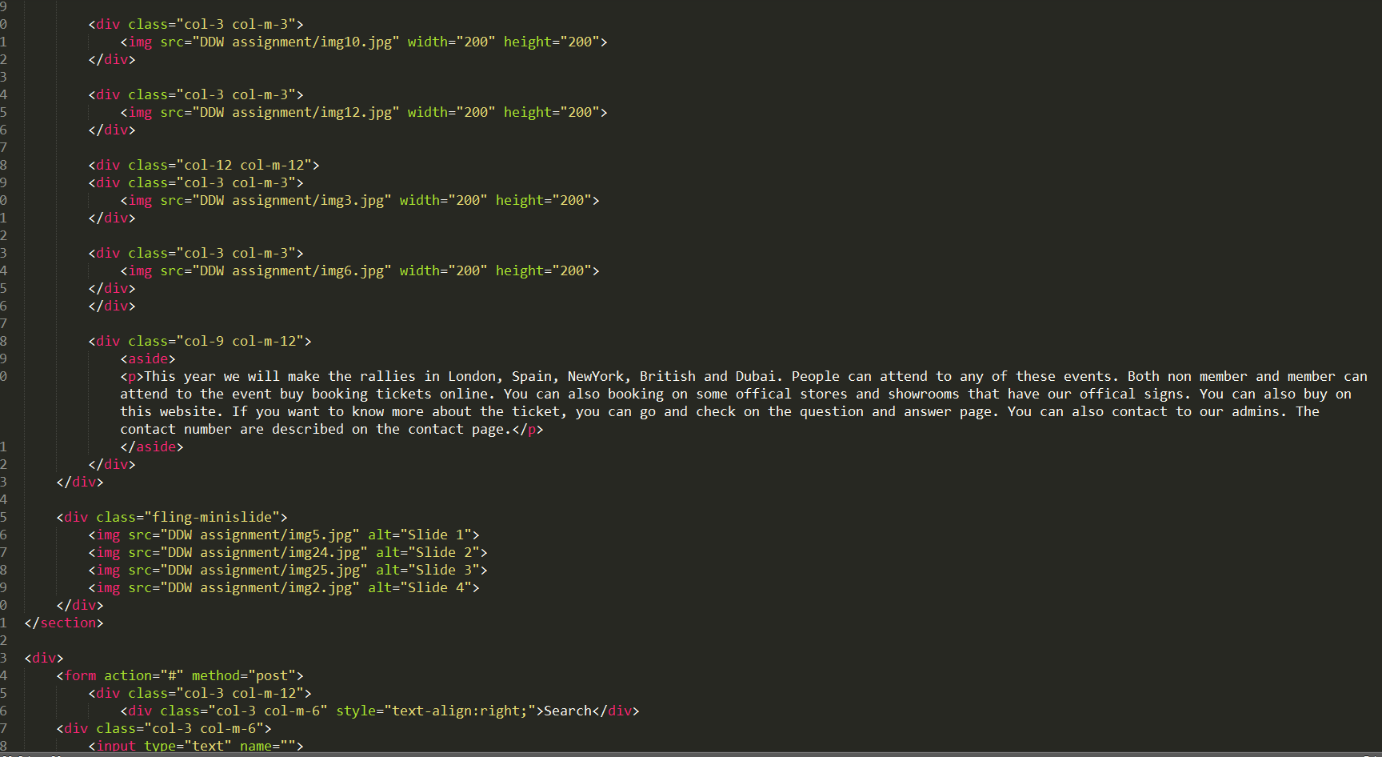

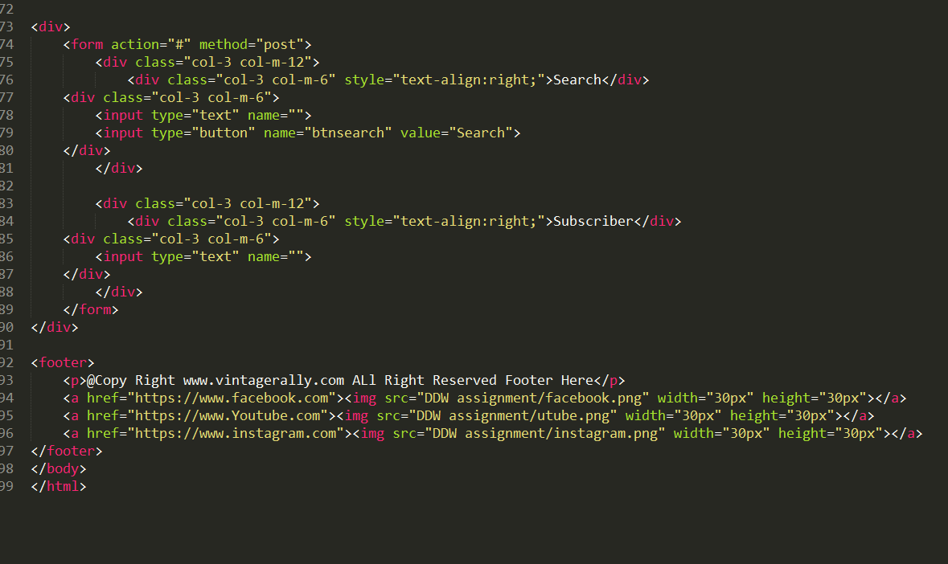

Contact Us page

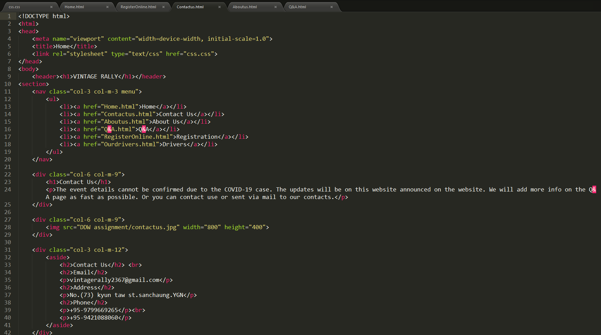

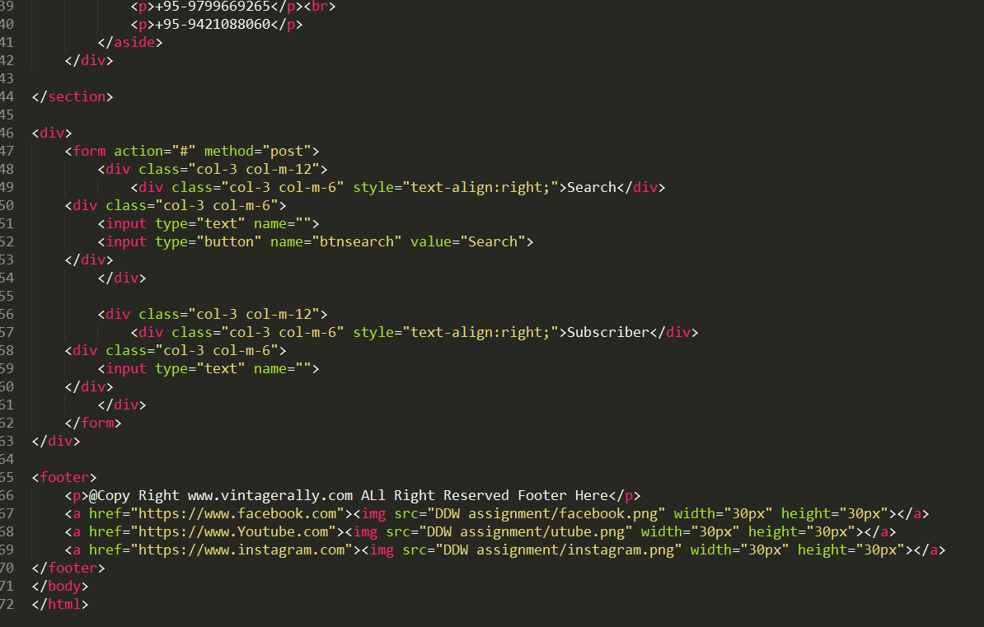

About Us page

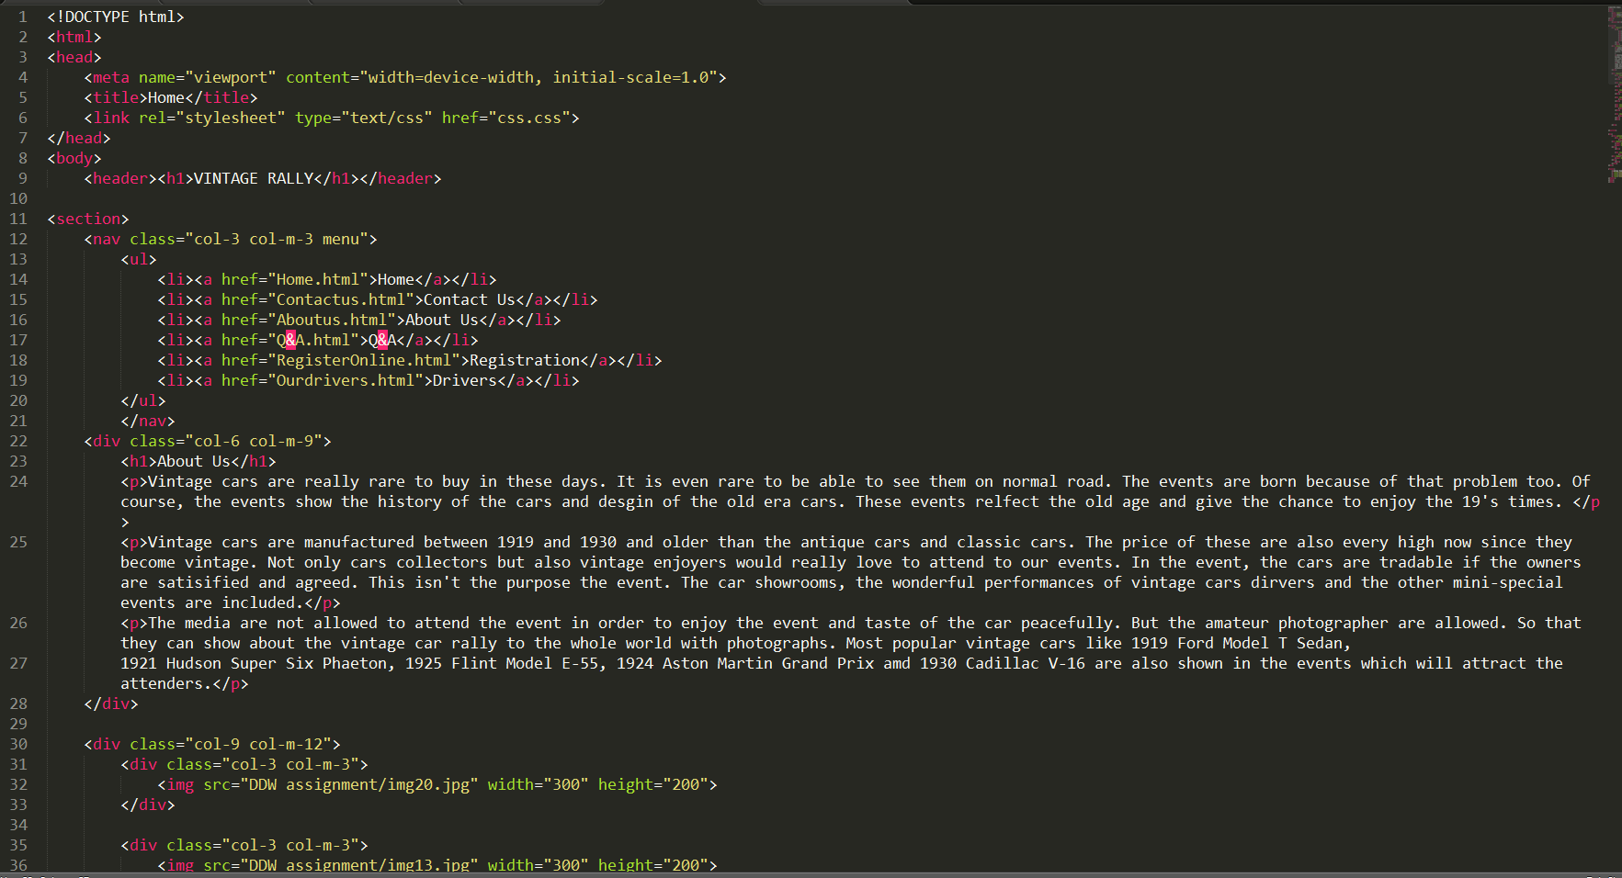

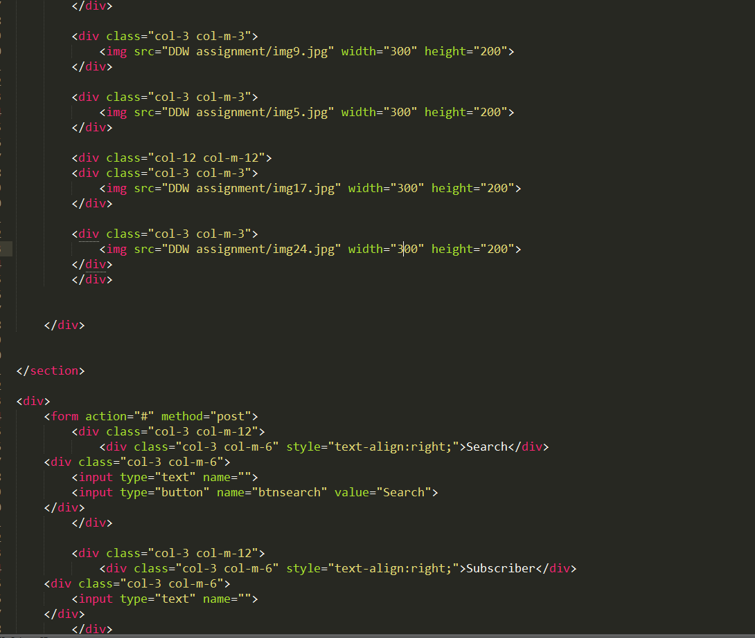

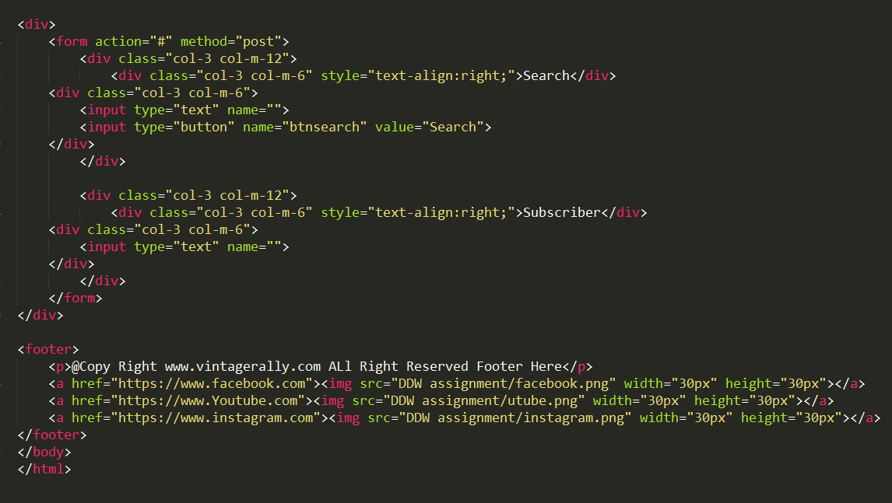

Q&A page

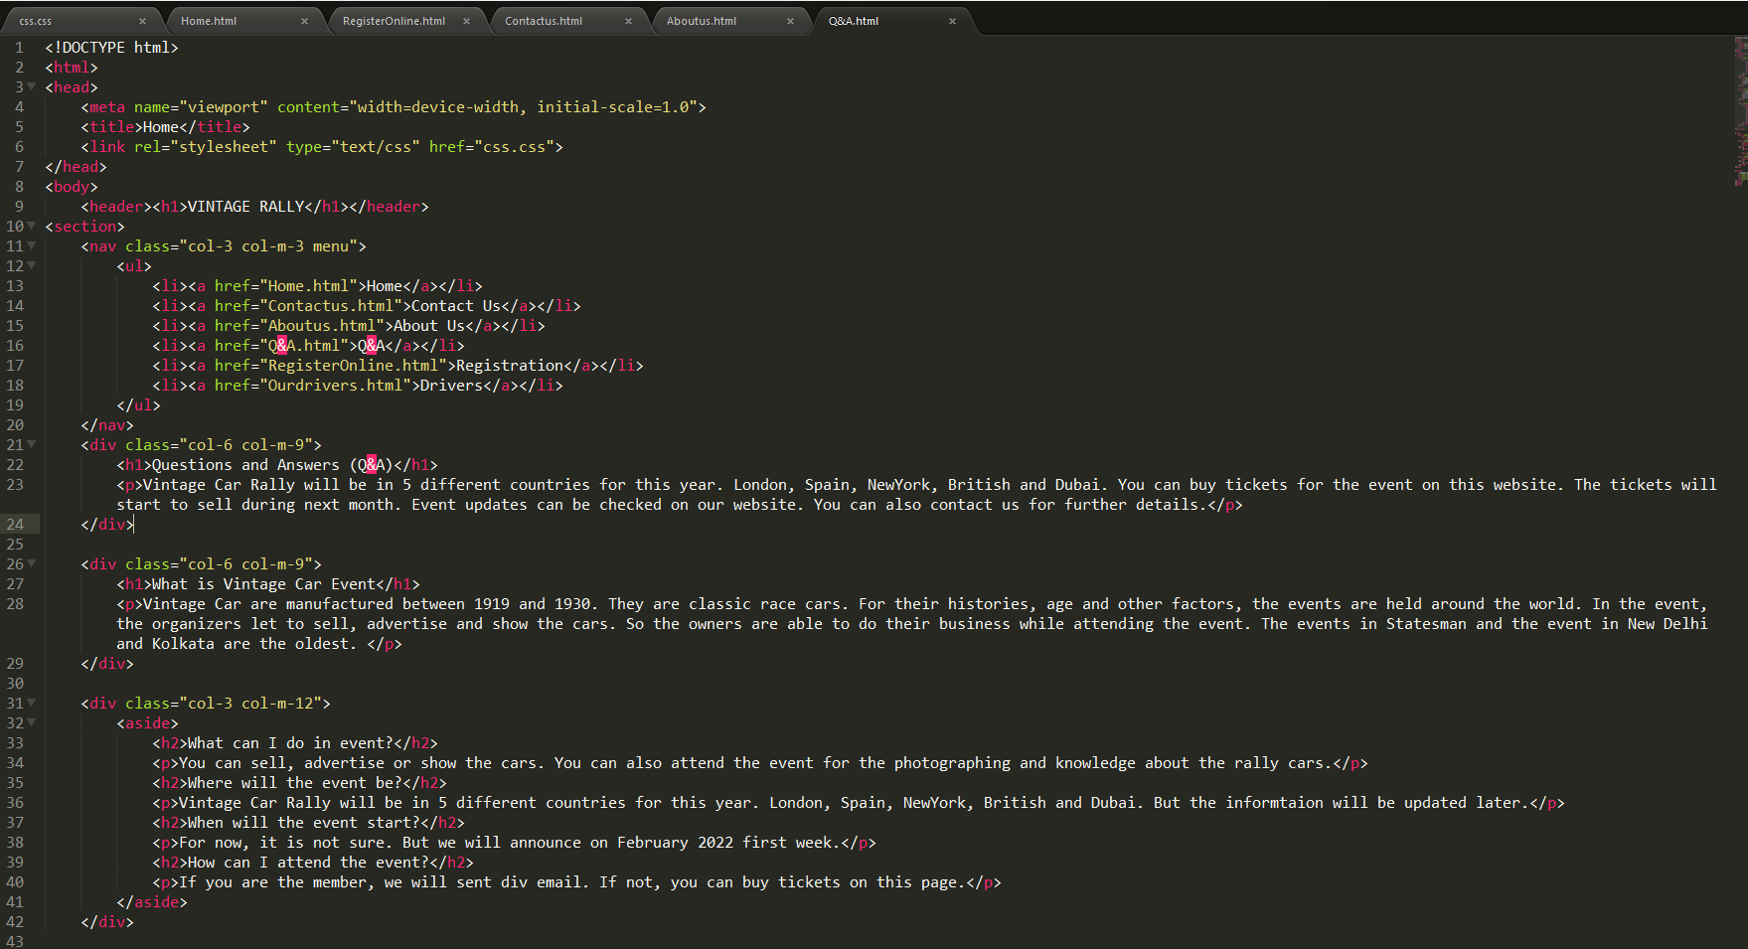

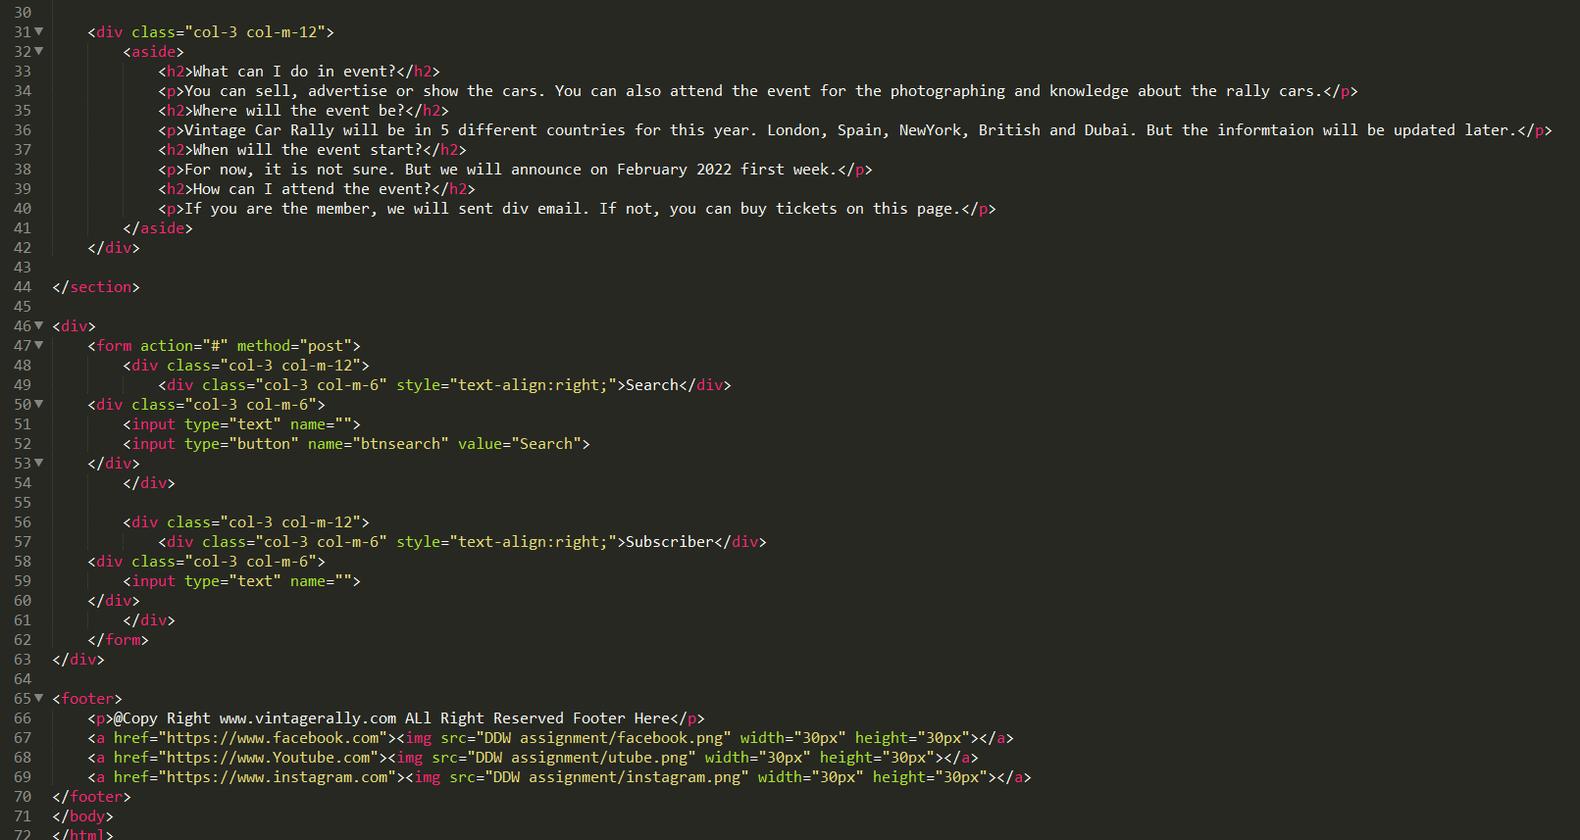

Register Online

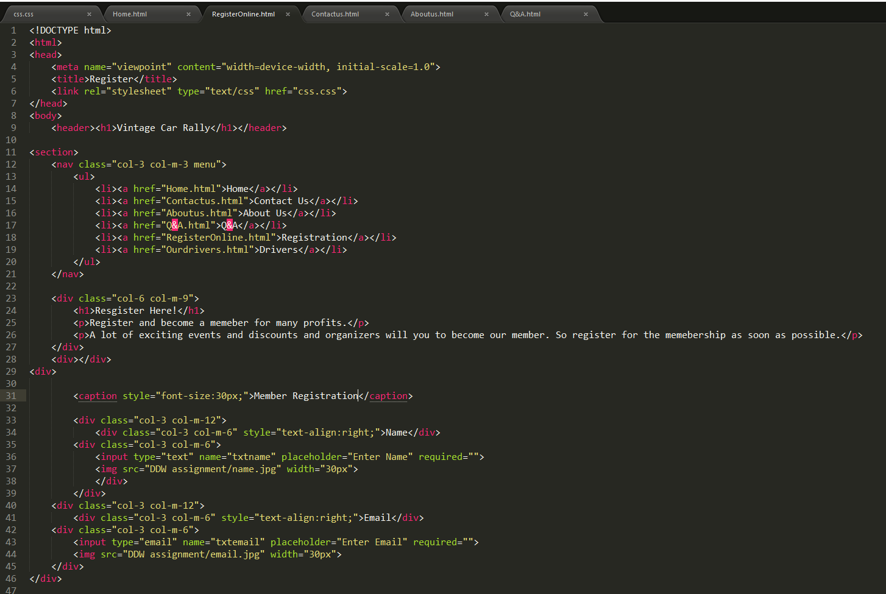

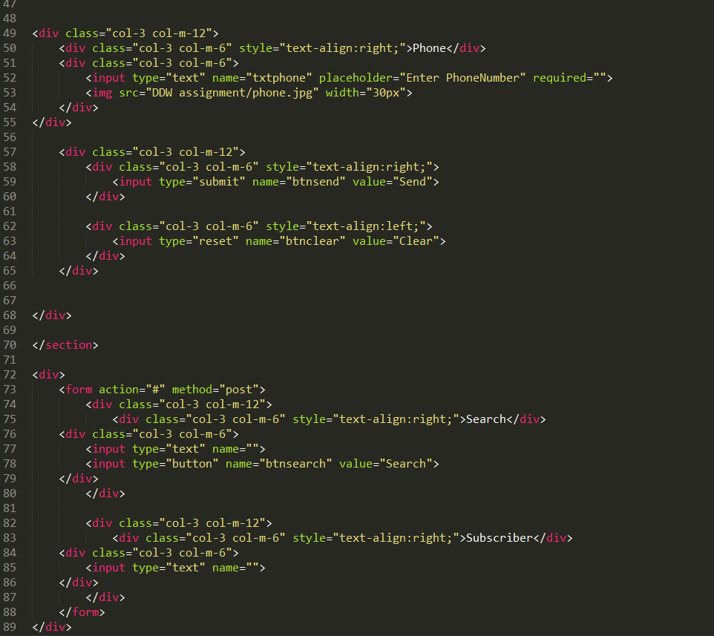

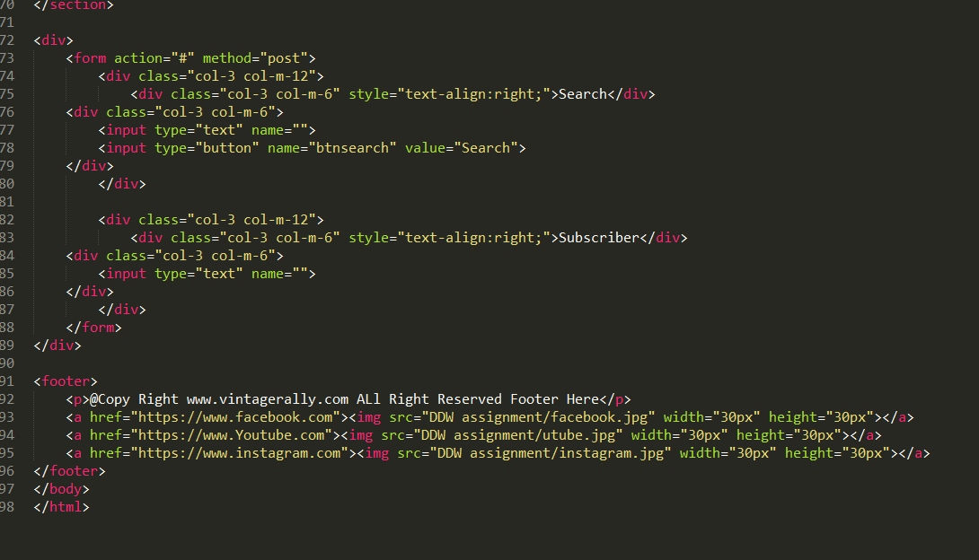

Our Drivers page

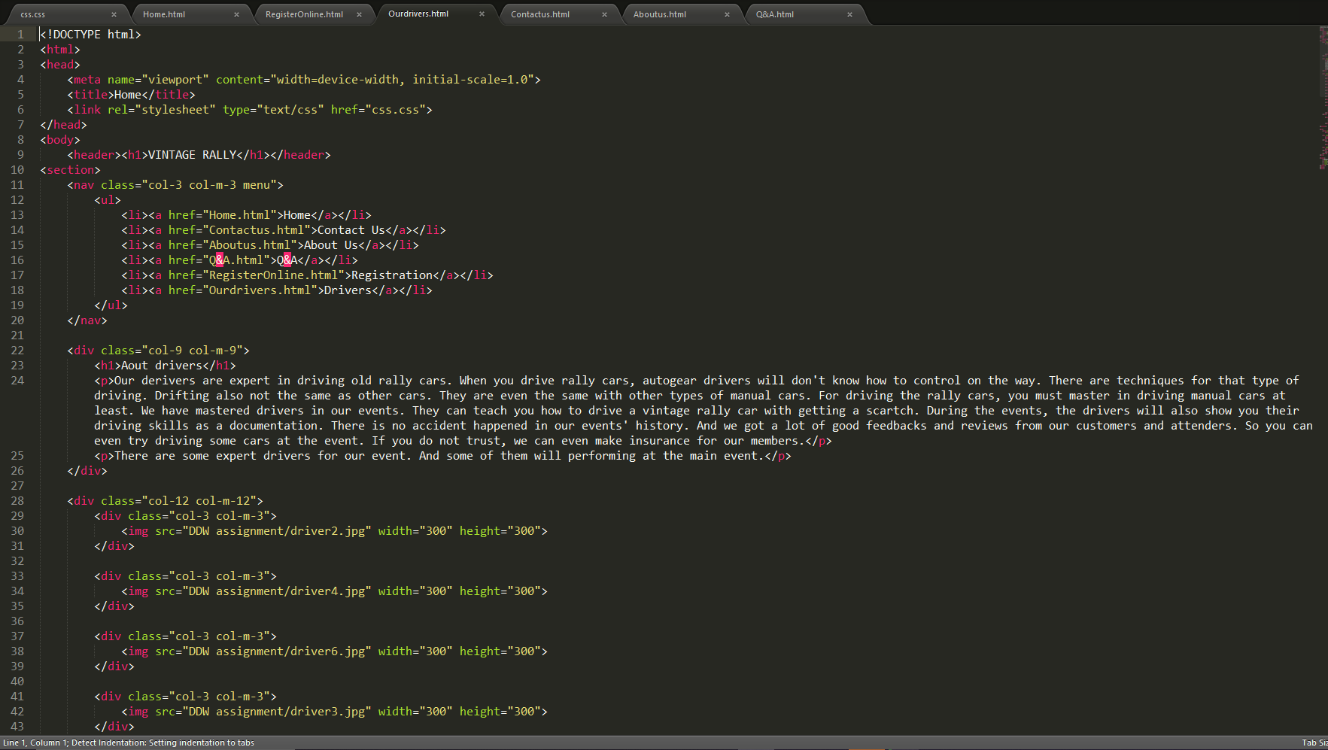

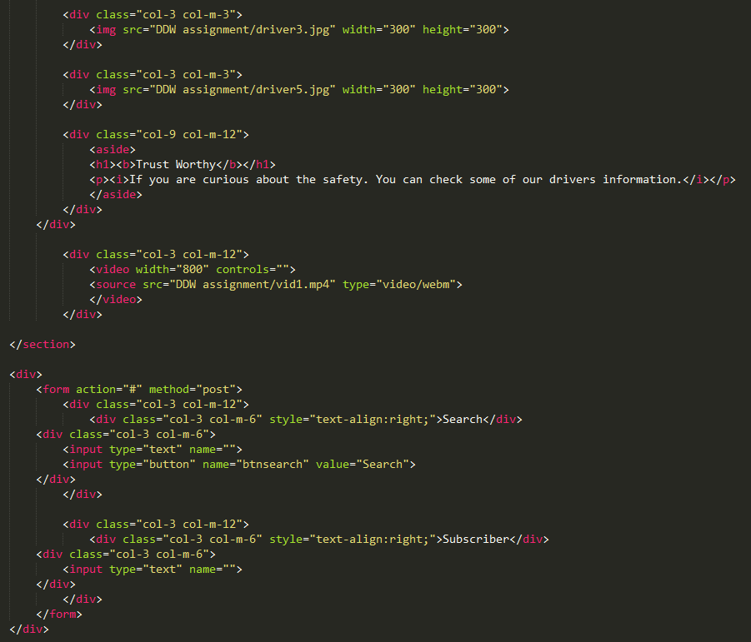

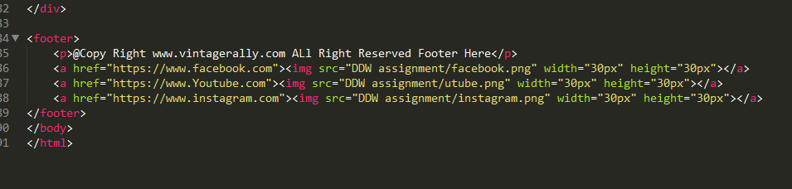

**Task 2**

**CSS**

# Task2- CSS Print Screen

# 

# 

# 

# 

**Task 3**

# Task-3 Test the website and write a test report

## Testing the Website on W3C validation service

**Use the W3C validation service (**[**http://validator.w3.org/**](http://validator.w3.org/)**)**

**Check Home page**

When checking home page on validator, a lot of errors occur. Especially those are because of having bad values. Most errors are because of bad value and some of these errors are fixed.

**Check Contact Us page**

Contact us page have the same errors. It is showing bad value because of the folder’s which save images. So the name has to change into better one which would suitable with the rule of validator. But contact us page have fewer images than others so the amount of errors are lower than the others.

**Check About Us page**

About us page is the same like contact us page. It have small number of image. So the amount of error is lower. But another errors like size of images are existed. Thus the size are fixed into proper one.

**Check Our Drivers page**

At first, this page had a lot of errors because of images size. After checking the size are changed into better one which will also good for disable users.

**Check Q&A page**

In this page, the images are only used for footer so technically lowest amount of errors are occurred. But they are also fixed and this page is the only page that has lowest amount of errors.

**Check Register Online page**

This page also has as the same as the other pages. This page doesn’t have normal size images. So most errors are not fixed for the prefer appearance.

## How the website works for Disable users

The website also works for disable users. This website doesn’t have irritating colors and shining brightly colors. The colors are on this page are some of suitable colors of six tertiary colors, three primary colors and three secondary colors. The website also works with the screen reader. The screen reader named NVDA is used and all pages and texts, images (including the text from images) are read. (usability.gov).

## Testing on Two Different Web Browsers

When testing on Firefox and Chrome, the results are clearly different. First different is the font. The font in Firefox is better looking than in the Chrome. And the second different is the video. Watching video in Firefox is convenient than in the Chrome and have better performance. The third different is the images. Images in Firefox seem to have better resolution than those of Chrome.

## Test Report

The website had errors during running. The style of web and links of web were wrong. So they are fixed.

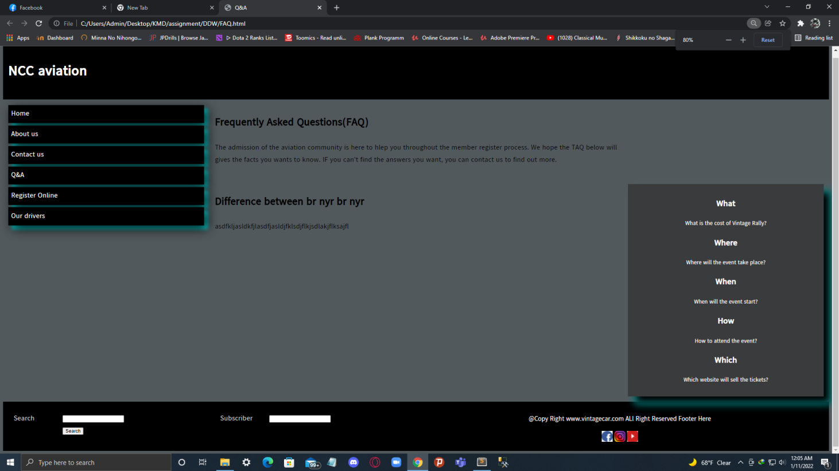

In this page, the colors and contents were wrong.

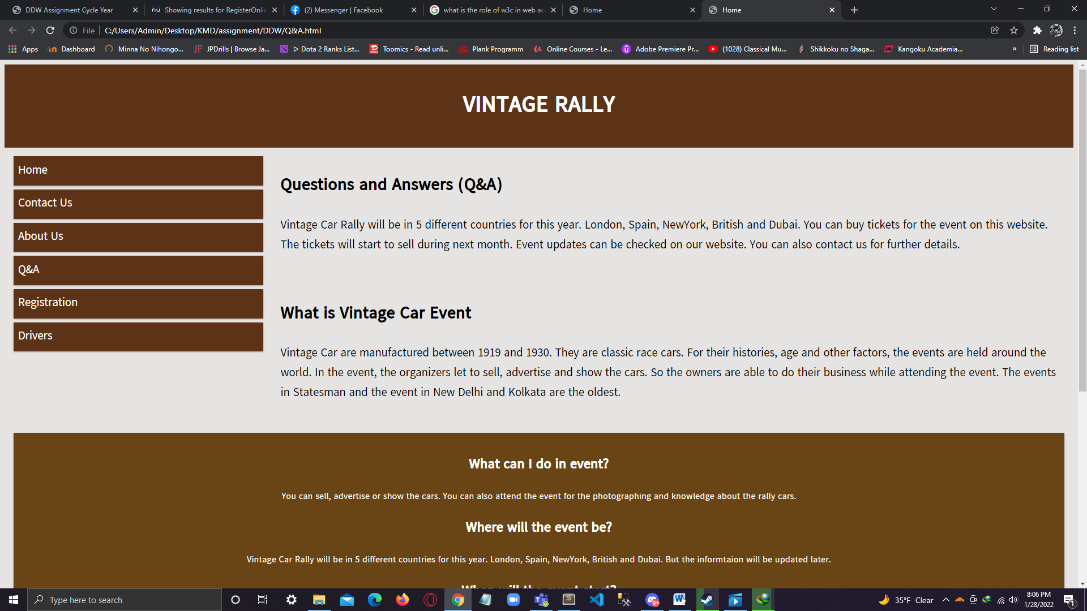

And later fixed into proper one and content are changed.

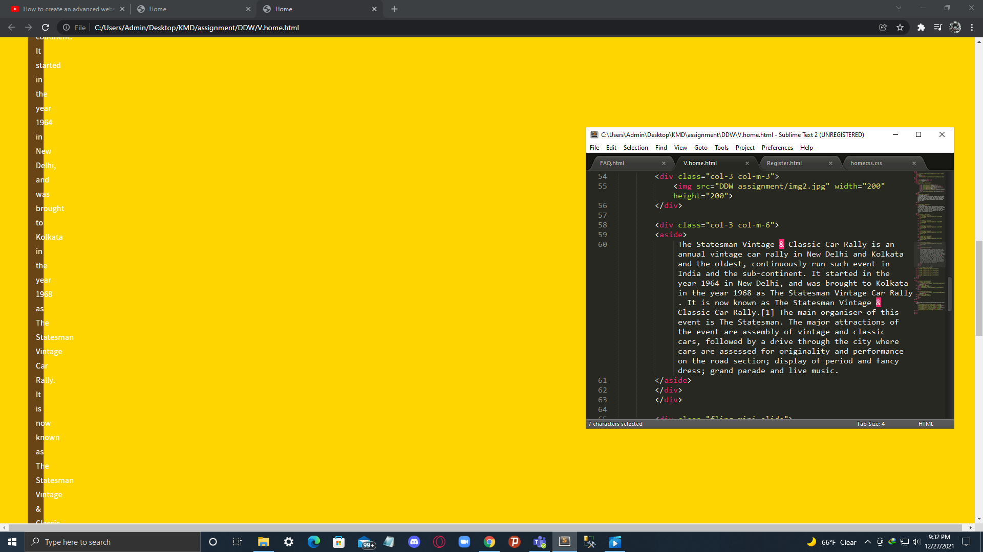

In this page, the div are wrong and the pictures are not shown.

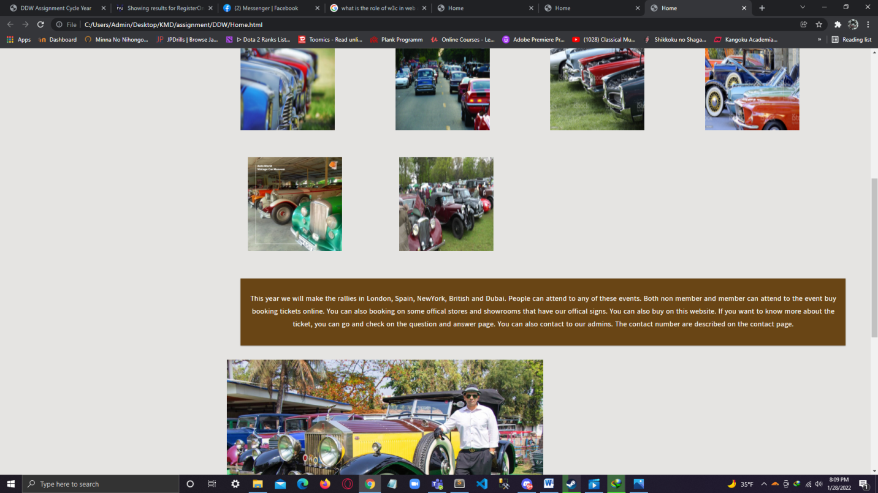

This is the fixed result.

## Role of W3C

W3C (abbreviation the World Wide Web Consortium) helps the industry to develop guidelines and resources to make the Web accessible to all type of people. The organization takes information from the people which are from IT industry, disability organizations, government, and research labs and made a rule for web accessibilities. The staffs are working together to develop web standards and the organization is led by Tim Berners-Lee who is web inventor and director and CEO Jeffrey Jaffe. (W3C)

**Task 4**

# Task-4 Critical Evaluation

## Demonstrate a Two accessibility features have in your own website.

Used the good HTML headings and accessible images are two accessibility features that have in my own website. The headings on the website are accurate and written the necessary factors. The most images are jpg for better quality and accessibility features. These images are also not repeated and sizes are not irritating. These images are also well selected and used in good ratio for the disable users.. (Wuniversity of washington).

## Functional multimedia components the website have

The website has functional multimedia components like JPG, PNG and MP4. Most images are JPG images. Images on footer and small images were used PNG images. And the video on the over drivers pages is Mp4.

## Discussion on how the Internet and Web can be used for the Vintage RallyClub as a business tool

Since the website is created, the population of Vintage Rally Club will get higher and the market place will be wider. Everyone around the world will know more about the Vintage Rally Club and its events. These cars were difficult to buy in past years. Now with the help of the website this case will be easier. And the members in the club can communicate each other and can have chances to get more friends because of the club. Historians can also do more researches because of the website. Marketing of the vintage cars will be easier and the marketing can be done easily on the website. The conclusion is about that the club will become popular and the marketing, the sales including trading, researching and communication will be better and easier for because of the Internet and the website.

## Further development for the website

The website needs to develop further more in the future. The website needs to be able to sell the real tickets and needs booking systems also. The payments are also be able to save and check at any time. Members should be able to chat each other on the website community. And the memberships are also needed to save and can be able to check. Trading and the selling are also able to do on the website in the future. Mostly the backend parts are needed in the website and needed to be development in the future. And some frontend feature are also needed for everyone. Some popular features like pop-up navbars are also needed for the further development. News are needed to be update on the real time on the website. This website needs to be visual on the internet surface. So that everyone in the membership and people who love vintage cars can found this website easily. And also needs to be more popular in the future so that everyone can be to know about the community and organization. The website should be more smooth to use and more responsive on the different devices such as phone, tablets, desktops, laptops and even on the foldable phones.

# References

# Bibliography

*usability.gov.* (n.d.). Retrieved from usability.gov: https://www.usability.gov/how-to-and-tools/methods/color-basics.html

*W3C.* (n.d.). Retrieved from w3c.org: https://www.w3.org/Consortium/

*Wuniversity of washington.* (n.d.). Retrieved from washington.egu: https://www.washington.edu/accessibility/web/

Candidate checklist

|  |  |
| --- | --- |
| Have your read the NCC Education documents ‘What is Academic Misconduct? Guidance for Candidates’ and ‘Avoiding Plagiarism and Collusion: Guidance for Candidates’ and ensured that you have acknowledged all the sources that you have used in your word? |  |
| Have you completed the ‘Statement and Confirmation of Own Work’ form and attached it to your assignment? |  |
| Have you ensured that your work has not gone over or under the recommended word count by more than 10% |  |
| Have you ensured that your work does not contain viruses and can be run directly? |  |